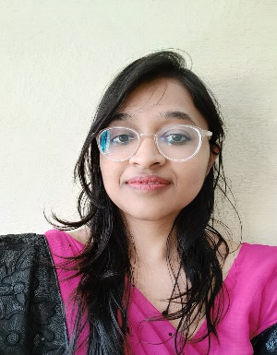

PALAK MITTAL

Mobile:+91 9536670570

+917017435095
Email:palakmittal33@gmail.com

OBJECTIVE:

To have growth oriented and challenging career where I can contribute my knowledge and skills to the institution and enhance my experience through continuous teaching and teamwork.

EDUCATION QUALIFICATION:

Examination | Discipline/  Specialization | School/college | Board/  University | Year of Passing | %
B.Ed | MATH & SCIENCE | Himalayan college puhana Roorkee | HNBGU | 2018-2020 | 76%
M.Sc | MATHEMATICS | K.L.D.A.V. College, Roorkee | HNBGU | 2013-2015 | 76.67%
B.Sc | PCM | S.D. Girls PG College, Roorkee | HNBGU | 2010-2013 | 68.72%
12 | PCM | Greenway Modern Sr. Sec School,Roorkee | CBSE | 2009-2010 | 70%
10 | MATHS | Greenway Modern Sr. Sec. School, Roorkee | CBSE | 2007-2008 | 69.2%

PROFESSIONAL EXPERIENCE

- 17/08/2017 – 15/08/2019 Teaching Assistant at K.L.D.A.V (PG) College, Roorkee Of Mathematics.
- 03/11/2019- Present Assistant Professor of Mathematics in METHODIST GIRLS P.G. COLLEGE, ROORKEE

ACHIEVMENTS

Qualified JAM in 2013
Qualified GATE in 2017 with AIR 376
Qualified GATE in 2018 with AIR 402
Qualified NET-LS in JUNE 2017 with AIR 26

TECHNICAL SKILLS:

Packages : Ms-Office

CO- CURRICULAR ACHIEVEMENTS

- Participated in Inter college Debate Competition.
- Participated in Essay Competition.

PERSONAL SKILLS

- Sharp understanding, Target specific approach, persuasive communication

PERSONAL DETAILS:

Date of Birth : 25 AUG 1993
Father’s Name : Mr. AJAY KUMAR MITTAL
Gender : Female
Marital Status : Unmarried
Linguistic Abilities : English & Hindi
Address : House no. 343 Moh. Kayesthan, Manglaur (ROORKEE)
Nationality : Indian

DECLARATION

I hereby declare that all are above information is true and correct to the best of my knowledge and belief.

Date:
Place:

(Palak Mittal)

